An anchor element with an implicit href attribute would be written as follows:

https://techacademystorage.blob.core.windows.net/htmlandcss/href.png

a href="https://learncodinganywhere.com/">Check out The Tech Academy!</a>

<!DOCTYPE html>

<html>

<body>

<a href="https://www.w3schools.com">Visit W3Schools.com!</a>

<iframe width="420" height="315"  
src="<https://www.youtube.com/watch?time_continue=1&v=28xjtYY3V3Q>">  
</iframe>

</body>

</html>

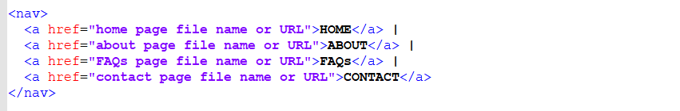

<nav>

<a href=”home page file name or URL”>HOME</a>

<a href=”about page file name or URL”>ABOUT</a>

<a href=”FAQs page file name or URL”>FAQs</a>

<a href=”contact page name or URL”>CONTACT<a/>

</nav>

<a href="<https://www.youtube.com/watch?time_continue=1&v=28xjtYY3V3Q>">DogvsBear</a>

<https://www.youtube.com/watch?time_continue=1&v=28xjtYY3V3Q>